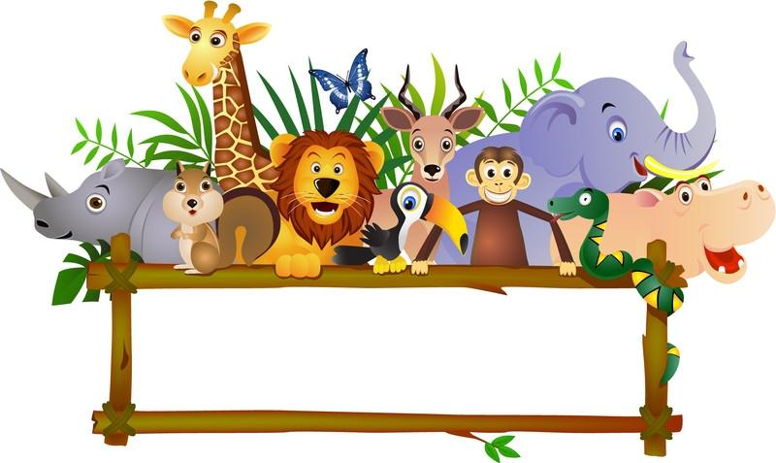

**VIRTUAL ZOO**

*TEAM MEMBERS:*

*Antoinette Attipoe  
Kayode Onaolapo   
Gregory Jones*

*May 8, 2012*

**Goals and Objectives**  
Our group envisioned a virtual zoo that can be used as an educational tool to teach children about animals. Hence, the goal of this project was to create a virtual zoo that mimicked a real zoo. We also wanted to create some interaction between the animals and the humans in the zoo to make interacting with the virtual zoo more entertaining and to help children enjoy the process of learning. The virtual zoo for example, can help children learn the names of the animals, their characteristics, their habitat and their behaviors. This virtual zoo will also be particularly helpful if a child, for example, is afraid of physical animals and is terrified to go to real zoo. This virtual zoo can give the child the opportunity to experience a real zoo in a virtual environment without being afraid of the animals. Hence, this can be a valuable tool in the hands of both parents and teachers. The simulation of this virtual zoo may also serve as a form of entertainment for anyone.

**Modeling**  
The virtual zoo environment we envisioned was an outdoor zoo. The whole layout will be covered with grass. There will be four layouts to the zoo. The layouts will house different animal species. We will create a section called the African Savanna that will hold animals like the lion, tiger and cheetah. We will also have an ape house, a birdhouse, an aquarium, reptile and amphibian house, panda habitat, an elephant house, a dinosaur showcase, a petting area and an area, displaying penguins. To make this zoo more realistic, we will add people, trees, terrain and other landscaping elements. We plan to use 3d models, textures (to make plain objects more realistic), animations, and behavior functionalities.

**Project Implementation**

For this project, we used 3ds max and VRML software. 3ds max was used for modeling the virtual environment, the animals, humans and landscape. We also used the animation functionality in 3ds max to include some interactivity among the objects in our virtual environment. There were some functionalities of VRML in 3ds max like the touch and time sensors. We used those to also add some functionality to our object models and scene.

**VRML Functionality**  
We incorporated VRML functionalities in animating the virtual zoo. We used basically touch sensors for the animation in the virtual zoo.

**The Designed Environment**

The final virtual zoo had four layouts and included all the animal species we initially set out to include. One section of the zoo housed the aquarium which contained sea horses, dolphins and fishes. The areas were designed in a way make the sections of the zoo accessible to people but at the same time protecting them from the animals. So the African savanna section for example is had a fence surrounding it whereas zoo visitors could get close to the aquarium to view it. Some of the more dangerous animals were kept either in a cage or in an enclosed area where visitors could only view from a distance. We used a 3d model water fountain to create the habitat for the penguins. We also created a petting area where kids especially could go and pad farm animals. Different species of elephants were put in the elephant house. The birdhouse also contained different types of bears. For most of the animals, we had to attach skin textures to them to make them look more realistic. We created an entrance to the zoo and included signs indicating the various sections of the zoo. All modeling and some animation was done in 3ds max. Then the zoo layouts were exported into VRML where additional animation was carried out.

**Materials Used for Creating the Virtual Zoo**Geometry - Very little geometry was used for this project. A box was used to design the various signs for the various sections of the zoo including the sign for the main entrance.

Textures - We used skin textures for the animals in the zoo. We also put textures on the signs for the zoo and the grass as well.

Animation – We animated movement throughout the various sections of the zoo. Hence, one can go from one section of the zoo to another by just clicking or pressing a button on the keyboard. Also we animated some of the movement of the animals and people in the zoo.

Functionalities – The goal here was to add some interaction between animals and humans. We used a touch sensor for example to create some interaction between a person and an animal. So for example, when you click on an animal, the animal moves towards the person.

**How This Application Can Be Used (User Manual)**

This application does not need a user manual because it is very easy to use. All a user needs is vrml viewer such as cortona3D or cosmo player. Once the user presses play on the viewer button, the user can use the PC mouse to navigate their way through the virtual environment.

**Why This Application Is Useful**As mentioned earlier, this application is useful because it can be used as an educational tool to help children learn about animals; their names, what they look and what they sound like.

**Why Virtual Reality is an Appropriate Technology**

Virtual reality is an appropriate technology for this project because it provides us with the functionalities to simulate a virtual environment.

**Problems Encountered**

The first problem we had was with the use of the 3ds max application. Modeling was a challenge and time consuming. Team members were not familiar with all the functionalities of 3ds max needed to complete the project. So the team had the learn how to apply the functionalities to their modeling process. This slowed down the project considerably. The team also had a problem exporting the models from 3ds max to vrml. However, this was resolved. We were also short-handed as one member was not able to assist with the project. The work load grew heavier and we were not able to implement all the functionalities we set out to include in the virtual zoo.

**Shortcomings**

Because modeling the objects in the virtual environment took longer than expected, the team could not include many of the intricate details we wanted to apply to our models.

**Recommendations For Further Improvement**

More animals can be included to this virtual zoo. Also, some animal skin textures can be applied to some of the animals to make them look more realistic. More animation and interactivity between animals and animals, animals and humans can add a realistic feel to the virtual zoo.

**Software and Hardware Used**

3ds Max 2011  
VRMLPad 2.0  
Cortona3D/Cosmo Player  
Dell PC (Windows 7 Enterprise – 64 bit)

**Websites from which models and textures were downloaded**

[www.exchange3d.com](http://www.exchange3d.com)

[www.archive3d.net](http://www.archive3d.net)

[www.turbosquid.com](http://www.turbosquid.com)

[www.thefree3dmodels.com](http://www.thefree3dmodels.com)

[www.3dmodelfree.com](http://www.3dmodelfree.com)

[www.artist-3d.com](http://www.artist-3d.com)

[www.canstock.com](http://www.canstock.com)

[www.archivebase.net](http://www.archivebase.net)

[www.cgtextures.com](http://www.cgtextures.com)

[www.cadyou.com](http://www.cadyou.com)

Below are some screen shots of different scenes taken in 3ds Max.

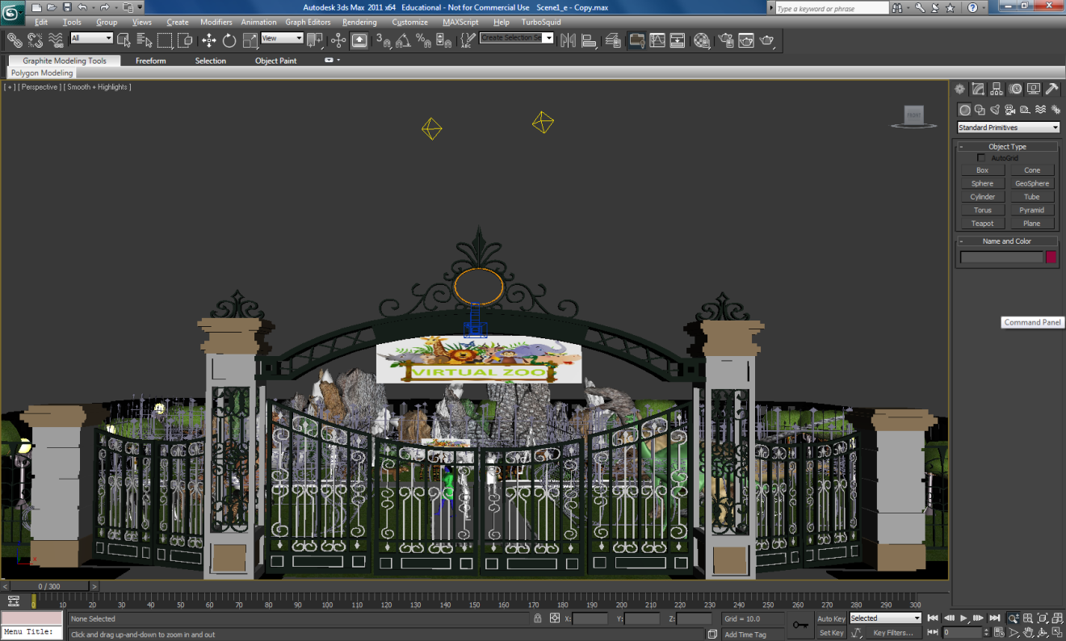

Figure 1: Entrance to the zoo

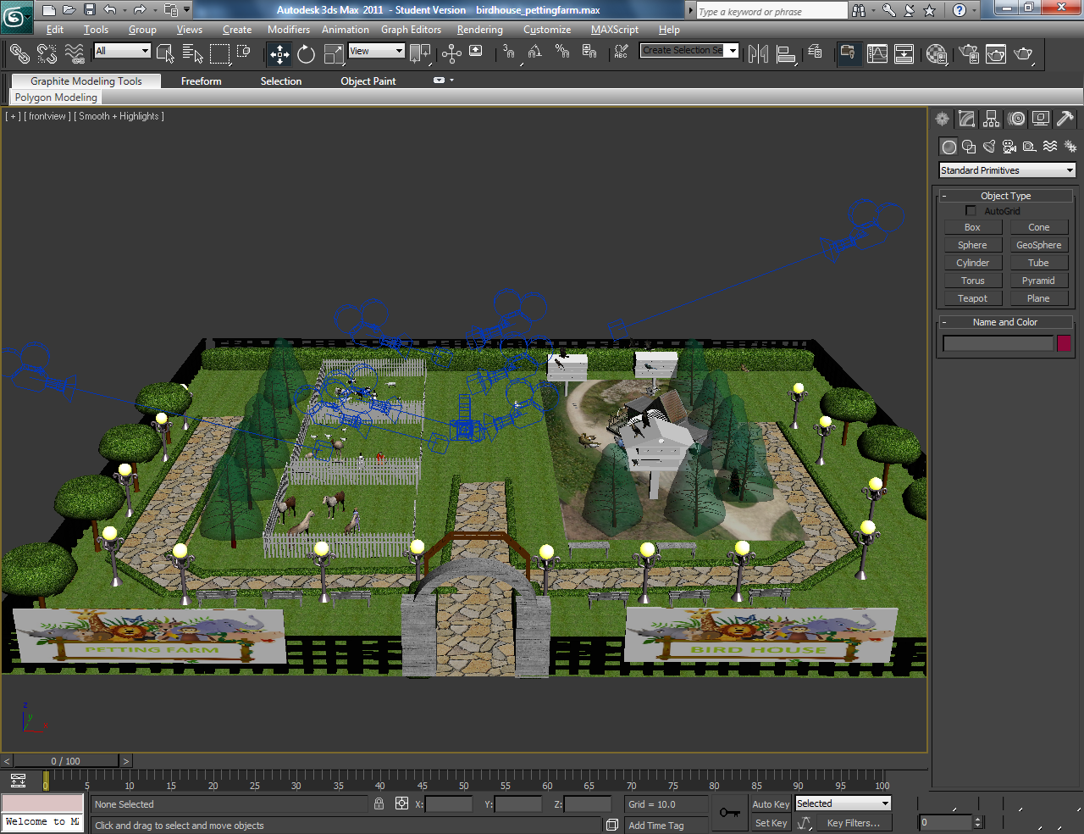

Figure 2: Petting Farm and Bird House

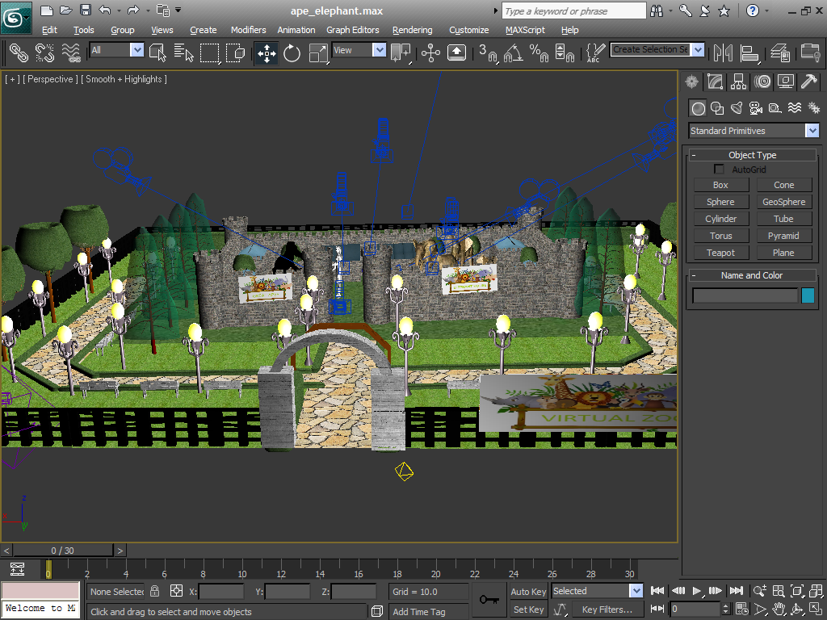

Figure 3: Ape and Elephant House

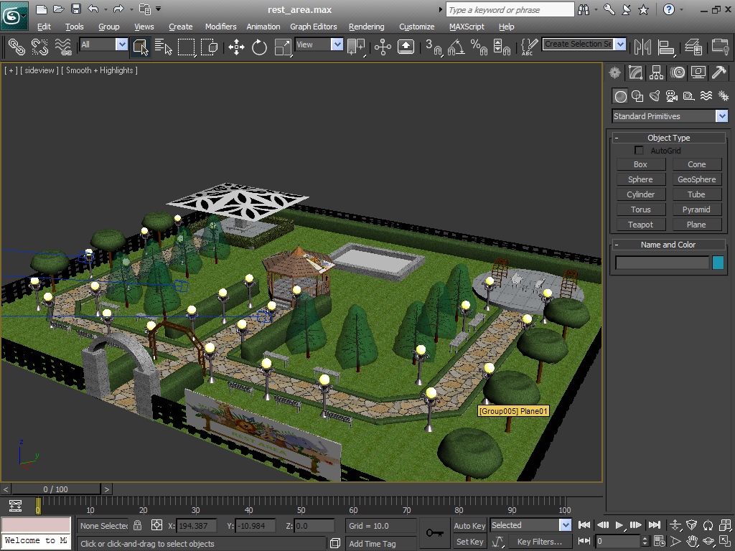

Figure 4: Rest Area

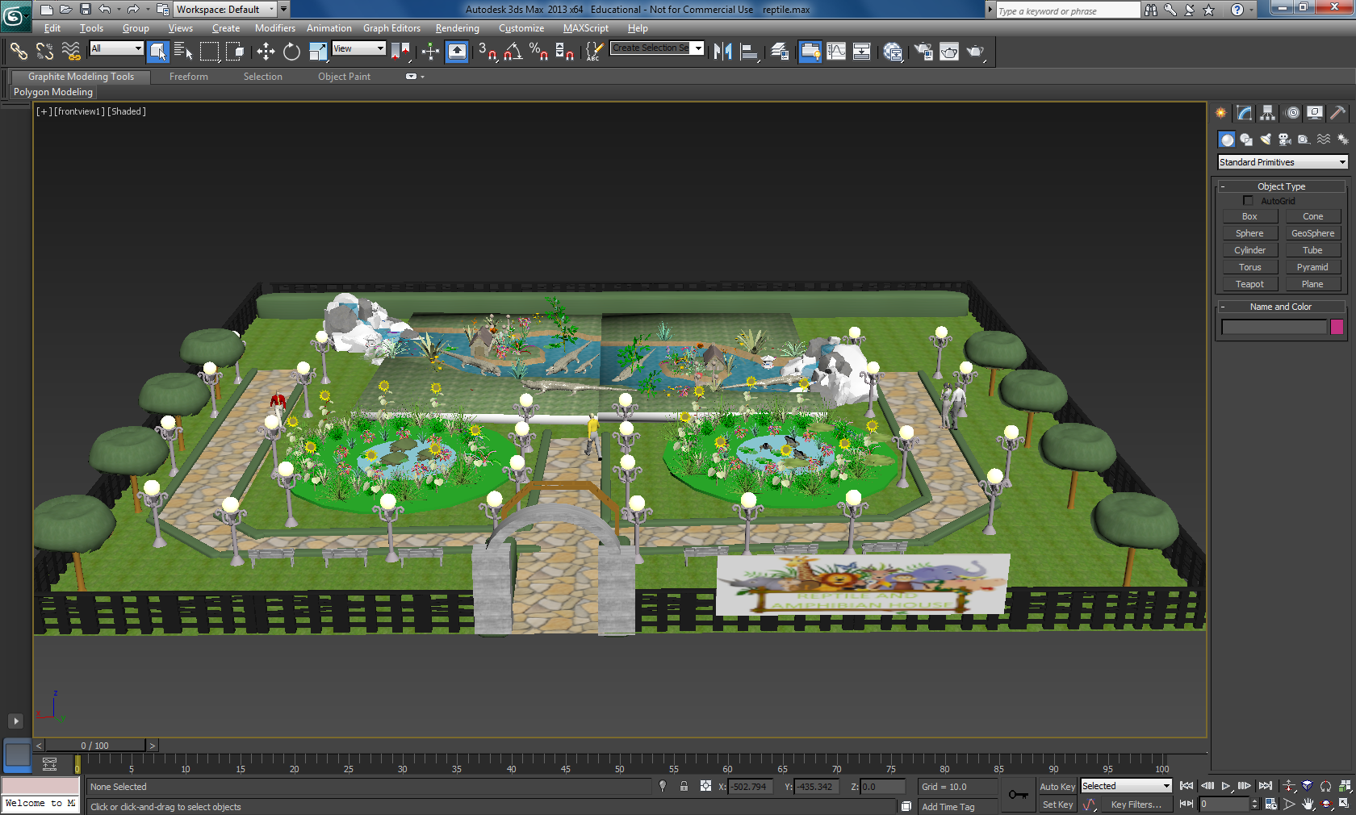

Figure 4: Reptile and Amphibian House

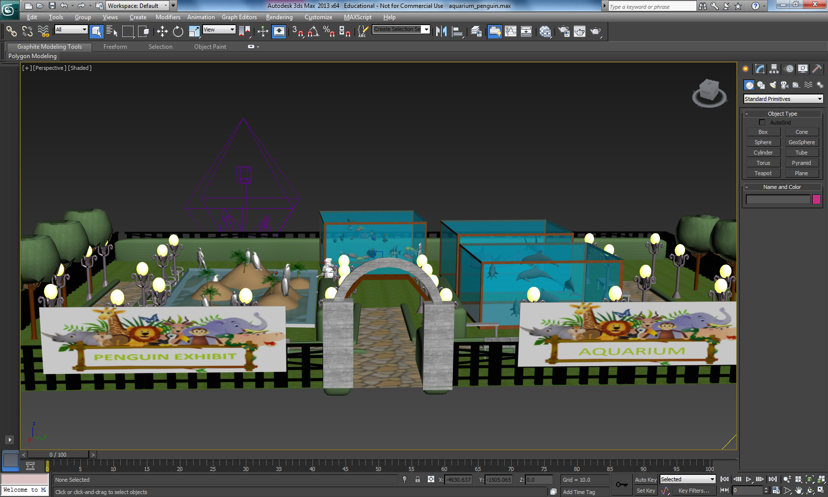

Figure 5: Penguin Aquarium and Penguin Exhibit